**Existential Restrictions**

Hello guys, learn by doing is the best way of self learning.I have read few ontologies and done some practice with ontologies such as Ballpoint , Pizza and Wine. I feel like creating a very simple ontology by myself is good way to go.I am planing to implement a shoe ontology here.With this few days of investigation I feel that before implementing the shoe ontology it’s good to know the shoe anatomy first.

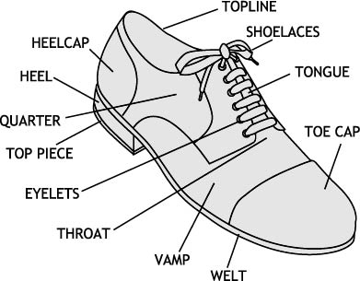

<https://www.feetcare.sg/blog/2016/8/16/different-parts-of-a-shoe>

Let’s pick few sub classes which are belongs to shoe class

* Canvase shoes
* Trainers shoes/ Athletic Shoes
* Military boots
* Lace Ups
* Ankle boots

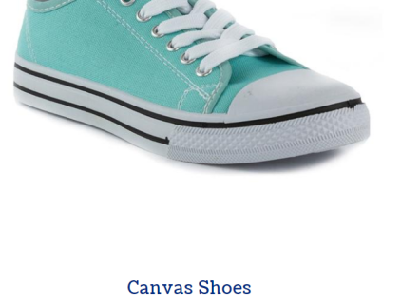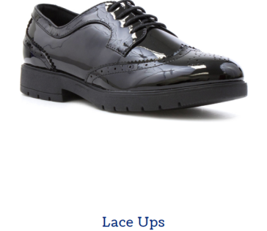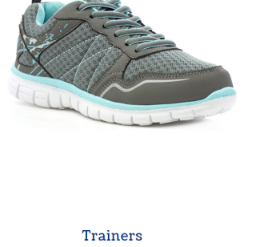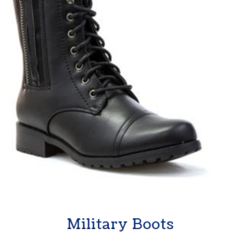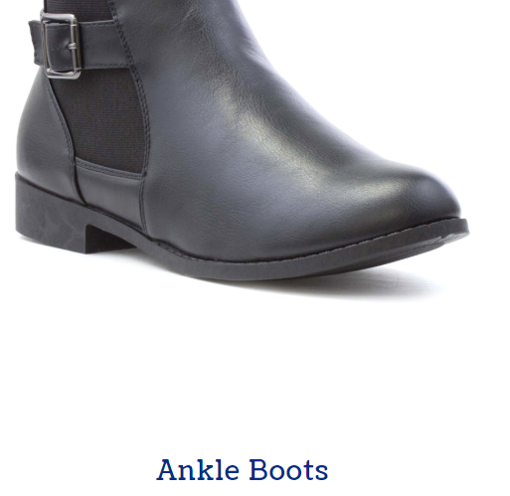

<https://www.shoezone.com/Womens/Womens-Shoe-Styles>

When we take Athletic shoes it has many sub classes such as

* Running Shoes
* Walking Shoes
* Tennis Shoes
* Basketball Sneakers and many more

For keeping the simplicity of the ontology we will keep only four sub classes from Athletic Shoe ontology.I always encourage you to study about shoes before starting practical modeling of the ontology.Lets think about the Ballpoint ontology and Pizza ontology.Even though you have used hundred thousands of ballpoints within your life time have you ever think about the types, components and features of a ballpoint pen.

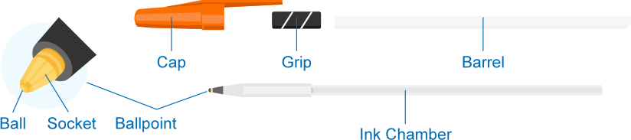

<https://www.qualitylogoproducts.com/promo-university/anatomy-of-pens-pencils.htm>

What are the characteristics of a shoe

* Cheap
* Expensive
* Flexibility and support
* Cushioning
* Waterproofing
* Shoe weight

Who are the popular shoe makers ? Lets pic few

* Nike
* Adidas
* Jordan
* Converse

Shoe Components (Shoe anatomy)

* Toe Cap
* Tongue
* Shoelaces
* Topline
* Heelcap
* Heel
* Quarter
* Top Piece
* Eyelets
* Throat
* Vamp
* Welt

Now it’s the time to prepare a lightweight visual model of our ontology

**WalkingShoes**

**Vamp**

**Topline**

**Shoelaces**

**Tongue**

**Eyelets**

**Throat**

**Heel**

**TennisShoe**

**ToeCap**

**CanvaseShoe**

**AthleticShoe**

**MilitaryBoot**

**LaceUp**

**HasComponent**

**ShoeManufacture**

**Shoe**

**ShoeCharacteristic**

**FootSupport**

**hasCharacteristic**

**hasManufacture**

**Nike**

**hasComponent**

**Adidas**

**Jordan**

**ShoeWeight**

**Flexibility**

**Expensive**

**Cushioning**

**Converse**

**Waterproofing**

**Cheap**

**Heelcap**

**BasketballSneaker**

**RunningShoe**